**205 - Assistive Robotic Aid for People with Duchenne Muscular Dystrophy**

**Sponsor:** Parent Project Muscular Dystrophy (PPMD)

**Sponsor Contact:** Mr. Keith Van Houten

**Faculty Advisor**: Professor Stephen Moyer

**ME 4015 – Engineering Design and Project**

**Submittal Date: 10/29/2024**

**Members and Roles:**

Brooke Harrington - Team Lead

Andrew Baum - Secretary

Omar Abuljobain - Treasurer

Justin Lee - Operations Assistant

Cavan Moriarty - Programming Lead

Table of Contents

Executive Summary 4

Background 5

Problem Statement 6

Objectives and Requirements 7

System Architecture 7

System Level Objectives 9

Derived Requirements 9

Conceptual Design 11

Preliminary Design 14

System Diagram 14

Computer-Aided Design 15

Engineering Analysis and Prototyping 22

Electrical 24

Structural 25

Risk and Mitigation Plan 26

Project Management 27

Schedule 27

Budget 29

Conclusions and Future Work 31

References 33

Appendices 35

Table of Figures

Figure 1. System Architecture 8

Figure 2. Concept Screening 12

Figure 3. Concept Scoring 13

Figure 4. Concept #1: Combo Robotic Arm 13

Figure 5. Concept #2 – Assistive Toolbelt 14

Figure 6. System Interactions 15

Figure 7. Robotic Arm CAD Assembly 16

Figure 8. Case and Joystick mount 17

Figure 9. Permobil M3 Joystick Control Interface 18

Figure 10. Uni-track and Sliding Mount 19

Figure 11. WaveShare RoArm-M2S Robotic Arm CAD Model Assembly 20

Figure 12. ESP32 Circuit Diagram 21

Figure 13. WaveShare RoArm-M2S Robotic Arm Joint Diagram 23

Figure 14. Gantt Chart 29

Figure 15. Budget Excel Spreadsheet 30

Figure 16. Budget Expenditure Chart 31

Table of Tables

Table 1. System Level Requirements 9

Table 2. Derived Requirements 10

Table 3. Risk Cube 26

# Executive Summary

Duchenne muscular dystrophy (DMD) is a genetic disease that causes muscle degeneration over time, progressively weakening those affected as they age. People affected by DMD use motorized wheelchairs for travel, and often require assistance from another person or assistive technologies to complete daily tasks such as drinking from a water bottle or operating a door to enter and exit buildings. Although there are mechanical aids to help those affected, as the disease progresses, they are unable to hold these aids and require a device that can generate forces from small inputs such as the translation of joystick commands to force induced movements of a robotic aid. Progressive muscle weakness of DMD requires design, integration, and testing of an assistive robotic aid that provides range of motion (ROM) assistance to people with DMD, with a focus on tasks including operating an elevator button, operating handicap door buttons, and bringing a drink with a straw to the user’s mouth.

The most prominent solution on the market is the Kinova Jaco assistive robotic arm [1]. The Jaco has six degrees of freedom (DOF) that function as a shoulder, elbow, and wrist, with three end effector digits that are used to interact with the environment. It is operated through the wheelchair joystick and has a display for visual feedback. The main issue with the Jaco is its complex control mechanism and bulky size. Since it is controlled through the wheelchair joystick, the user cannot operate the arm and the chair at the same time and must toggle between the two. The Jaco is also relatively large, making it difficult to stow away when a user needs to travel. Additionally, the arm alternates between a two and three axis operation mode with five independent push buttons. The user would not only have to alternate between these two operation modes, but would also have to toggle between wrist control, finger control, and translational control. Similarly, when toggling between these different controls, the user would have to press buttons separate from the joystick handle, adding more work and complexity to the system. [2] Finally, the Jaco costs roughly $60,000 which insurance does not cover, making the Jaco a device not acquirable for most people. The combinations of cost and complexity from the chair-arm toggle and motor actuation make the Jaco a less-than-optimal aid for people with DMD.

To provide ROM assistance to people with DMD, team 205 will modify a robotic arm to fit on the mounting brackets of common motorized wheelchairs such as the Permobil M3 and Quantum. The robotic arm system will be mounted under the armrest of the wheelchair on the Unitrack rail which is embedded in the seat, and all processing electronics will be enclosed in a container that also carries the robotic arm. The robot will be controlled by a separate joystick that mounts based on user preference (ideally non-dominant side) so the robot and chair can be controlled simultaneously. The robot structure will be modeled similar to a Backhoe, excluding pneumatics. It will contain a “shoulder”, “elbow”, and “wrist” joint with rotation controlled at the mounting location, resulting in four DOF. In consideration of how people with DMD would operate a complex robotic arm, a simpler controller with reduced inputs can be designed that allows for intuitive control in a 3-D space. Intuitive control and simplicity through reduced DOF’s will reduce cost significantly and provide better ROM assistance than the complicated Jaco robotic arm. Lastly, the container design assists users in quickly removing the robotic arm with little complications, providing modularity in a way the Jaco does not.

Going forward, team 205 will finalize the design of the mount for the robot, electronics, and joystick. As the team finalizes an off-the-shelf robotic arm that utilizes an ESP32, the team will further research how an ESP32 microcontroller can be programmed with an Arduino for forward and inverse kinematic robotic calculations. As many programming alternatives are available, python development will be utilized in case the Arduino IDE proves to be challenging and ineffective. The team will finalize material selection and verify system functionality by testing the system’s ability to complete desired functions effectively. Following the procurement of a robotic arm, the team will purchase tools and materials necessary for case and mount development. Additionally, risk management plans will be further developed as a robotic arm has many failure points and the end user is physically incapable of stopping the robot if any aspect of the design were to fail. Following PDR, the team will have a representative model of the design prepared for the CDR that shows where the robot and controller will attach to the chair and how risks were addressed in the design.

# Background

DMD is a genetic disease that affects the muscles. It progresses as the person affected ages, causing the person to get weaker over time until the whole body is affected. In many cases, DMD also affects the respiratory system and requires those affected to use a BI-PAP, a noninvasive device that helps people breathe by pumping air into their lungs. DMD affects mostly men (1 in 5000) and affects about 20,000 babies each year. The symptoms of DMD fall on a spectrum: not every person affected with DMD experiences the same progression of symptoms. As these symptoms progress with age, users slowly begin to lose bodily functions such as walking and upper body movements, and therefore must utilize assistive devices and motorized wheelchairs to assist with mobility. While symptoms can be managed, there is currently no cure for DMD; however, organizations such as PPMD are researching ways to cure, prevent, or delay the progression of symptoms due to DMD. [3]

PPMD is a nonprofit organization that aims to end Duchenne muscular dystrophy. They provide resources for those newly diagnosed with DMD, advocate for policy change regarding healthcare, access, and insurance coverage, and fund research on DMD. PPMD is sponsoring team 205 with the goal of providing range of motion ROM assistance to people with DMD through a low-cost robotic arm that mounts on the rails embedded in common motorized wheelchair seats.

# Problem Statement

Currently within the DMD community, many available robotic aids are too expensive, obtrusive, or difficult to control. One such example is the most prominent solution on the market; The Kinova® Jaco® assistive robotic arm. While the arm provides users with high levels of dexterity, its numerous input controls make it challenging to operate. Additionally, it is priced around $60,000 and features a complex mounting structure that hinders quick removal when space is required. PPMD is interested in a solution to this problem as it would provide people with DMD an affordable solution equipped with the key functions needed to assist in interacting with the world around them. The team will work closely with a small group of people from PPMD who have DMD for the duration of the project. This interaction will provide insight into community needs and opinions that will guide the team’s design decisions, improving upon previous solutions and meeting the needs of people with DMD.

**Value Proposition**

Since there are many issues with current solutions on the market, the team’s solution will provide people with DMD an accessible robotic aid with a substantial decrease in costs, simplified controls, and ease of mobility through modular integration. The team’s solution will not only provide independence for people with DMD, but also allow people with DMD to interact with others their age to work on a project that benefits those with disabilities. An assistive robotic aid allows those with DMD to perform daily tasks independently, rekindling their capability to perform ranged upper body movements. Daily tasks include operating an elevator or handicap door button and moving a water bottle to their face to drink from a straw.

# Objectives and Requirements

To first determine what isneeded from a cheap, functional, and compact robotic arm, the team will break down the system into its subsystems, configurational items, and functions in the system architecture. Also, the team will apply modifications to the objectives and operations of the robot based on requirements put in place by the PPMD team or through safety and operating concerns in the system level objectives and derived requirements.

## System Architecture

Breaking down the problem into specific functions allows for a description of how possible solutions may operate to provide ROM assistance to people with DMD. The assistive robot contains three subsystems: the robot frame, the electronics, and the software, which will work together to provide ROM assistance. The subsystems are further broken down into configuration items and functions which specify the components and operation of each subsystem.

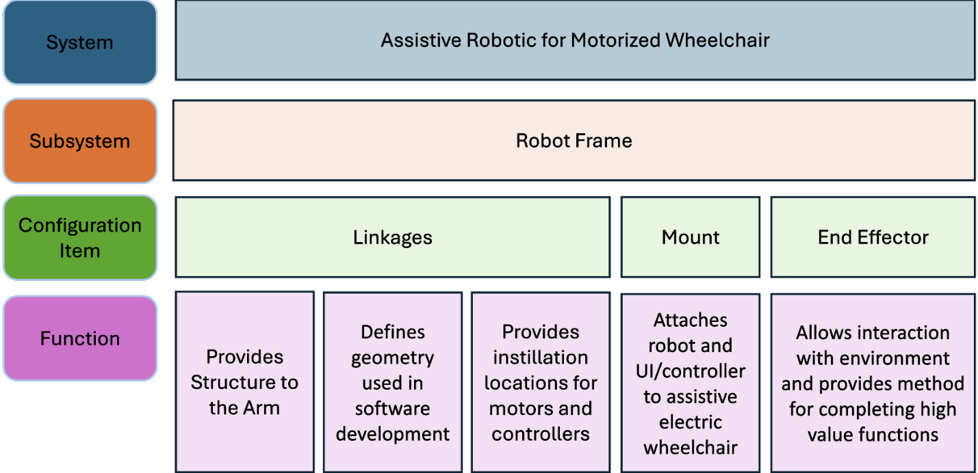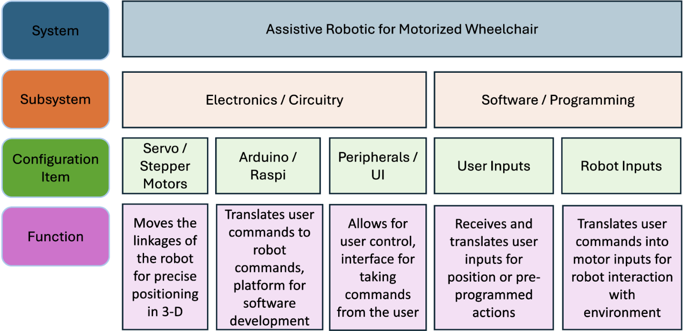

Figure 1. System Architecture

## System Level Objectives

Requirements are defined using the format “TR X.X.X” where 1.X.0 indicates a system level requirement, and the X indicates the requirement number (1.1.0 indicates the first sys. level requirement, 1.2.0 indicates the second sys. level requirement, etc.)

Table 1. System Level Requirements

|  |  |  |
| --- | --- | --- |
| Technical Requirement ID | Requirement | Verification Method |
| TR 1.1.0 | The robot shall be controlled manually by a joystick and should have the ability to program automatic functions accessed through a button push or voice activation | Test |
| TR 1.2.0 | The robot shall have no more than six degrees of freedom | Inspection |
| TR 1.3.0 | The robot shall have an operating radius that spans a minimum of 5 inches to a maximum of 2 feet from mount location with 180 degrees of rotation total | System Test |
| TR 1.4.0 | The robot should receive power from the motorized wheelchair battery and should include a backup battery | Analysis |

## Derived Requirements

Similarly to the *System Level Objectives,* the listed requirements utilize the “TR X.X.X” format. The first variable denotes the system level requirement, the second variable denotes the subsystem, and the third variable denotes the secondary subsystem. In other words, the first variable changes are based on five main system level requirements, which are referred to as categories. “TR 1.0.0” is the overall configuration, performance specification, and description. “TR 2.0.0” is the field use conditions and environmental effects mitigation. “TR 3.0.0” is the maintenance, installation, and service life. “TR 4.0.0” is the physical features and metrics. “TR 5.0.0” is the safety concern of the user and its surroundings. The second variable changes as it iterates from its corresponding category. Likewise, the third variable changes as it iterates from its corresponding subsystem. For example, “TR 1.1.0” is a one-time iteration requirement from "TR 1.0.0”, but “TR 1.1.4” is the fourth iteration of “TR 1.1.0”. Overall, the numbering nomenclature is useful in categorizing iterations of systems.

Most derived requirements were developed through consulting with the team’s customer. As an example, under Table 2, the derived requirement TR 1.1.2 was reached through consulting customers with DMD. This requirement constrains the system to manual joystick and automatic button commands which eases the overall operation of the system. Requirements with size or shape specifications were determined through understanding standards set in place for wheelchair users. As there is a limited workspace the powered wheelchair can operate around, the size of team 205’s solution plays a key role. This is seen in requirement TR 1.3.1 where there is an overall height requirement the robotic arm must reach in order to operate as intended. This requirement was determined through ADA standards for button and object placement with wheelchair users in mind [4].

Table 2. Derived Requirements

|  |  |  |
| --- | --- | --- |
| Technical Requirement ID | Requirement | Verification Method |
| TR 1.0.0 | The team shall research, design, develop, integrate, and test an assistive robotic device modified for a motorized wheelchair including a custom mounting device, electronics, and software | Customer Feedback |
| TR 1.1.0 | The robot shall be controlled manually by a joystick and should have the ability to program automatic functions accessed through a button push or voice activation | Test |
| TR 1.1.1 | The joystick shall be attached in a location near the motorized wheelchair armrest | Visual Inspection |
| TR 1.1.2 | Any automatic functions shall be independent of the joystick and should operate without any joystick inputs | System Test |
| TR 1.1.3 | The arm shall not mount in a location that infringes on the user's seating space, and must be small enough that as installed on wheelchair, the user can still pass through a standard door opening | Physical Inspection |
| TR 1.2.0 | The robot shall have no more than six degrees of freedom | Inspection |
| TR 1.3.0 | The robot shall have an operating radius that spans a minimum of 5 inches to a maximum of 2 feet from mount location with 180 degrees of rotation total | System Test |
| TR 1.3.1 | The device should be able to reach and depress elevator buttons and the handicap door button between 34" and 48" as specified by ADA standards | System Test |
| TR 1.4.0 | The robot should receive power from the motorized wheelchair battery and should include a backup battery | Analysis |
| TR 2.0.0 | The robot shall operate in dry, arid conditions and should operate under rainy, humid conditions | System Test |
| TR 2.1.0 | The robot electronics shall be contained in a weather resistant enclosure | Material Test |
| TR 2.1.1 | The robot motors shall be secured in a weather resistant sleeve | Material Test |
| TR 3.0.0 | The robot shall be installed in less than one hour and should be operational within thirty minutes of installation | Timed Test |
| TR 3.1.1 | The robot shall be disassembled and reassembled for maintenance in less than three hours | Timed Test or PM/M Plan Development |
| TR 3.2.0 | The robot shall require maintenance every year and should be cleaned and inspected every 3 months | Analysis / PM/M Plan Development |
| TR 4.0.0 | The system shall be neutral in color and should blend into the motorized wheelchair structure | Visual Inspection |
| TR 4.1.0 | The system shall contain no sharp edges and should minimize sharp corners on frame, end effector, and joystick | Visual/Physical Inspection |
| TR 5.0.0 | The robot shall not cause harm to the operator in any way. | System Test |
| TR 5.1.0 | Upon startup, the robot shall have safeguards against unexpected energization | System Test |
| TR 5.2.0 | The robot shall have physical or program safeguards to prevent it from reaching undesired locations | System Test |

# Conceptual Design

Team 205 generated three concepts each, resulting in a total of fifteen concepts to be down-selected from. Concepts developed included multiple robotic arms, “toolbelt” style concepts where specific functions were placed in specific locations on the wheelchair, and “utility box” concepts where multiple functions were contained in a box in one location on the chair. All concepts developed by every member can be found in appendix A.2. Concepts were generated based on the developed requirements. The first criteria states that the system shall have an operating radius spanning five-inches to a maximum of two-feet, whilst having 180° degrees of rotation. Secondly, the concept shall focus on simplicity, such as limitations on inputs and actuators to control the device (joystick, buttons, etc.). The third criteria accounts for how the device may be mounted onto the wheelchair including ease of installation. The remaining criteria focus on the generalized size, cost, and safety.

Initially, many of the generated concepts were immediately discontinued due to complexity and safety concerns, though many concept ‘duplicates’ remained, such as robotic arms, utility backpacks, and “toolbelt” style concepts. As a solution, the team combined similar concepts, resulting in six combination concepts to undergo concept screening as shown in Figure 2.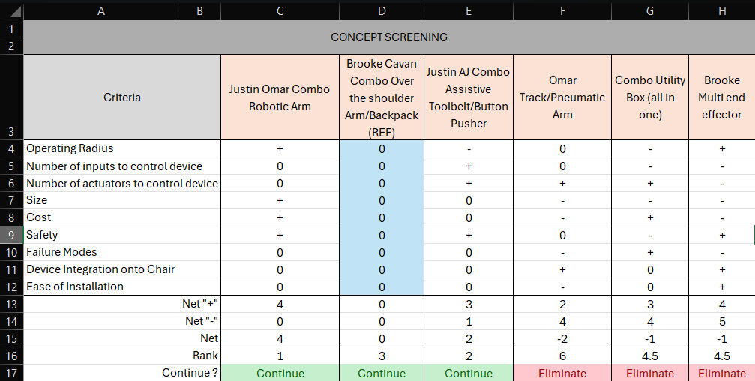

Figure 2. Concept Screening

As part of the concept screening, a reference concept was selected by evaluation of its relativity to the functionality of a human arm. Additionally, the reference was chosen such that each combination concept had aspects that were better and worse than the reference, thus, the screening would produce accurate, reliable results. The comparison displayed as a plus-minus-zero status was based on the concepts’ hypothetical design performance in the specific criteria rather than loose engineering calculations. For example, an assistive toolbelt may perform better than a robotic arm in the safety criteria since there are fewer moving parts. As a result, three combination concepts, including the reference, passed and were evaluated again through concept scoring while the others were eliminated. The concept scoring weighs the criteria based on the priority of customer needs and assigns ratings to the concepts based on how well they meet customer needs. This resulted in an overall score that determined “Justin Omar Combo Robotic Arm” and “Justin AJ Combo Assistive Toolbelt/ Button Pusher” as the final concepts, as shown in Figure 3.

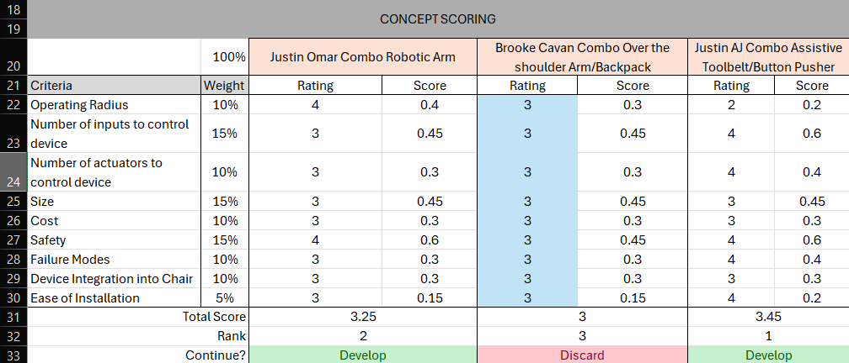

Figure 3. Concept Scoring

Lastly, the final two concepts, as well as the down selection process, were presented to the customer as “Concept #1-Robotic Arm” and “Concept #2-Assistive Toolbelt”. For better understanding, the concepts were redrawn as displayed in Figure 4 and Figure 5 respectively. Although both concepts fulfilled customer needs, Team 205 received highly suggestive feedback to continue with “Concept #1” since the customer felt this best aligned with their ideal solution. From there, further discussions were prompted regarding implementation of “Concept #1” including mounting points, dimensions, detachable features, etc. In summary, the team successfully down selected concepts through concept screening, concept scoring, and customer feedback.

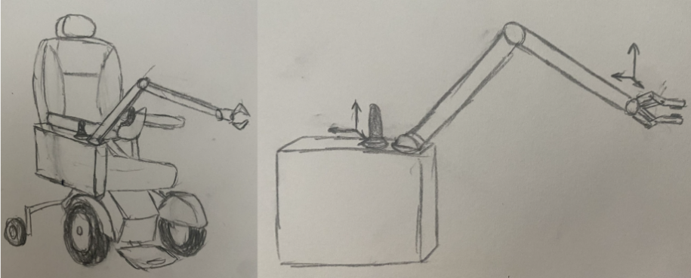

Figure 4. Concept #1: Combo Robotic Arm

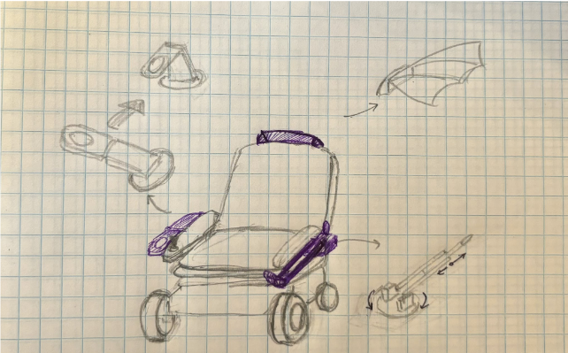

Figure 5. Concept #2 – Assistive Toolbelt

# Preliminary Design

## System Diagram

The team developed a system diagram for the robotic arm to describe how each component interacts with the others. As seen in Figure 6 the robotic arm will receive power from an external battery, with a kill switch installed in between these two components for instant de-energization of the system if there is a safety concern. The Arduino will take user control inputs from the joystick and convert these to motor inputs for the robotic arm. The robotic arm will send position feedback and power to the Arduino. The system diagram will be refined as parts are purchased and code is developed to include interaction specificity and provide a detailed understanding of system operation.

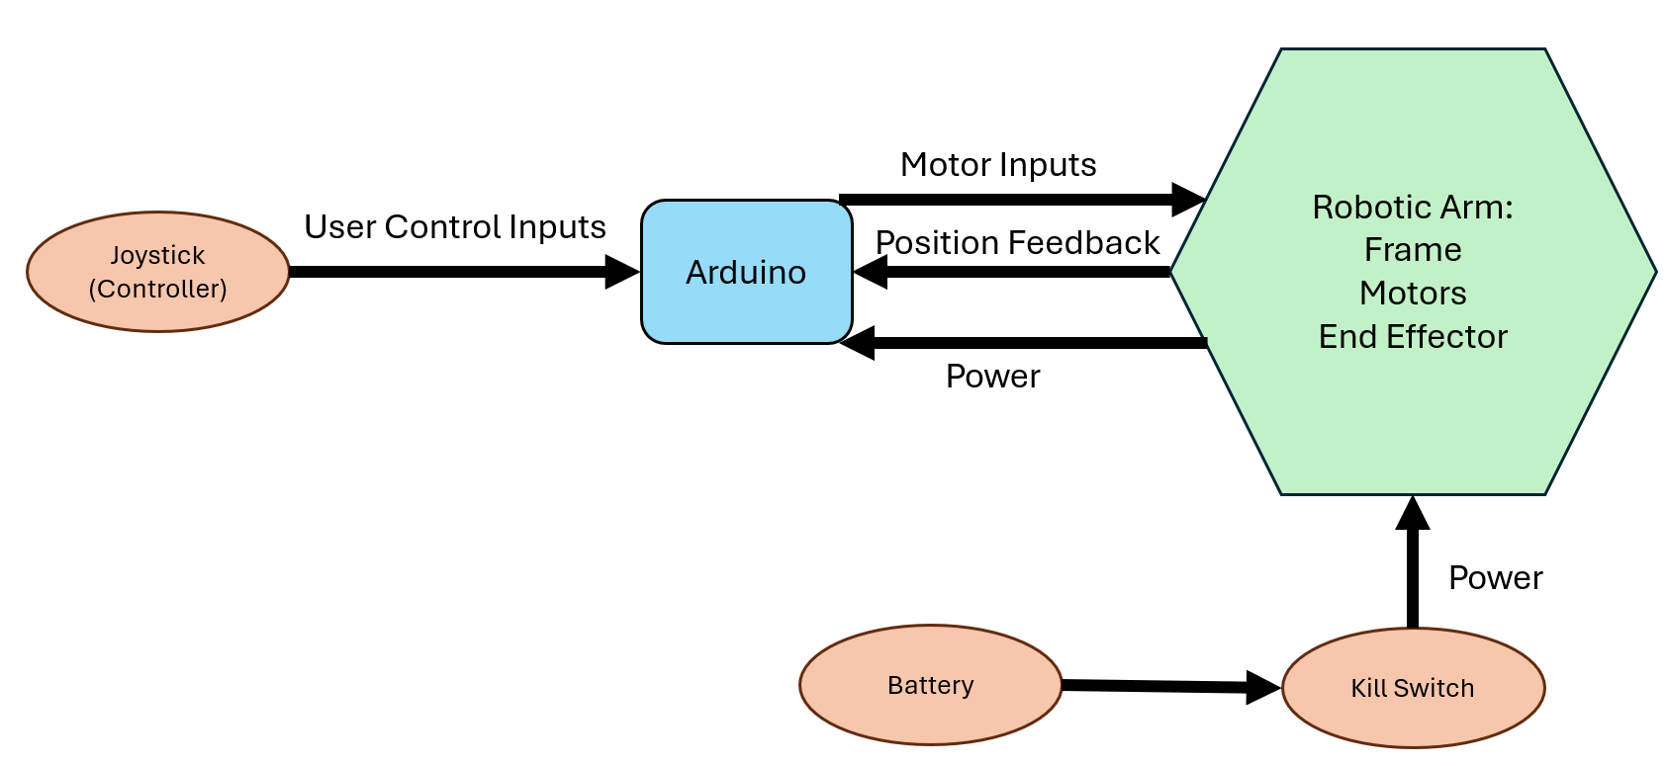

Figure 66. System Interactions

## Computer-Aided Design

Computer-Aided Design (CAD) for the robotic arm system consisted of generating models for three different parts: the case that holds the electric components, the mount that attaches the case to the Unitrack, and the joystick mount. The case was built to the maximum packaging envelope based off dimensions provided by PPMD members and the ADA requirements for a minimum door width. The case design will be refined as parts are chosen and the electrical component layout is finalized. Ideally, the case does not extend past the footprint of the wheelchair wheels and arms so that it is easy to remove for travel. The joystick design will be refined once a joystick is chosen, and proper measurements can be taken for mounting and space occupation. The current joystick CAD is meant to represent the mounting and space occupation of the future joystick. Additionally, the mount design may need to be refined depending on the available space on the user’s wheelchair and the depth of the Uni-track. Modifications will be documented as design choices need to be justified throughout the prototyping and testing process.

Figure 7 shows a CAD model of the entire system consisting of the joystick mount, case, robotic arm, powered wheelchair and wheelchair mount assembled. This image will be used as a reference when viewing the individual parts and putting sizes into perspective.

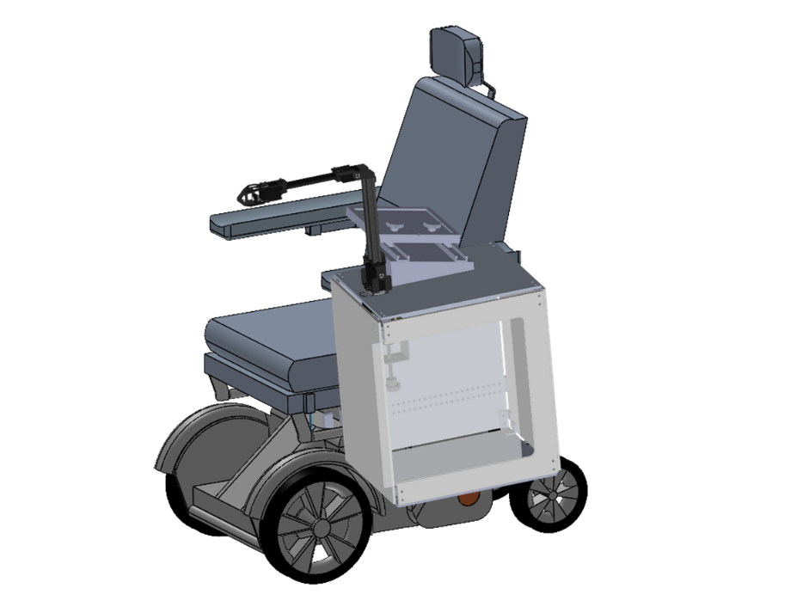

Figure 7. Robotic Arm CAD Assembly

The case and joystick mount are seen in Figure 8. To ensure both structural integrity with a lightweight design, the case will be made from aluminum. The simple case design allows for the use of aluminum sheets, which are malleable and easily cut, simplifying the manufacturing process. This material choice also considers the heat dissipation qualities of aluminum as it is a metal with a relatively high thermal conductivity at $237 W/m∙K$ [5]. This means that the case would be able to absorb the heat generated by the electrical components inside and dissipate it into the cooler outer environment. The dimensions of the case are based on the remaining footprint available between the Uni-track mounting location on the side of the wheelchair up to the width of an ADA compliant doorframe, which is about 13” of working space. The team has determined this to be the upper limit for the width of this system, with the lower limit being the largest component within the case which will be determined once all parts are finalized for purchase. The model gives a representation of the footprint the team can work inside, but further modifications will be made to the CAD model to fulfill the size requirements of the system. An acrylic panel will be installed on the face opposite the mount to provide easy access to the electronics and mounting hardware for maintenance and repair. Maintenance includes inspecting batteries, microcontrollers, wired connections, and screws for mounting.

To keep consistent with a light yet durable design, the joystick mount will be made of ABS 3D printed filament. This is due to its relatively cheap cost, light weight, heat resistance, impact resistance and rigidity [6]. The current footprint encapsulates a volume of approximately $60mm x 20mm x 150mm$ which converts to a total volume of approximately $11 {in}^{3}$. To keep the mount rigid and allow for screwed inserts, the recommended infill percentage will be $60\%$ of the total volume, which results in approximately $6.6 {in}^{3}$ of ABS filament being used [7]. Two aluminum Miter T-Tracks will be used for the sliding motion of the upper mount. The size of the aluminum Miter T-Tracks used will be $19mm x 9.5mm x 150mm$. The two knobs will add additional rigidity to the mount to keep it from deflecting when extended. The angle of the mount of the design mimics the angle seen joysticks of powered wheelchairs such as the Permobil M3 used by DMD consumers pictured in Figure 9. This angle provides the user with more comfort and accessibility to any additional inputs that would not be controlled directly via the joystick [8].

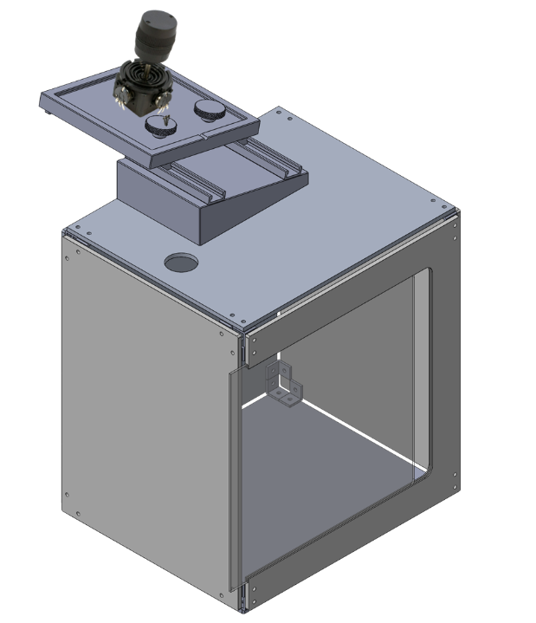

Figure 88. Case and Joystick mount

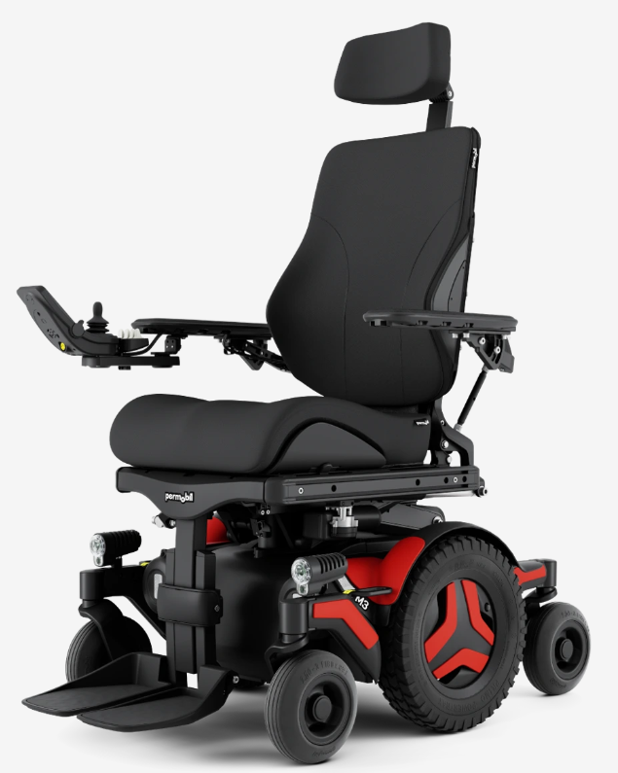

Figure 99. Permobil M3 Joystick Control Interface

Figure 10 depicts the sliding mount that attaches to the Uni-track. This mount will be manufactured using aluminum as it is a relatively cheap yet durable metal, costing approximately $\$1.202/kg$ [9]. The holes in the sliding mount design are used to mount the sliding mount onto the case which will slide on and off the Uni-track. The endcaps of the design are not only used as limiters to prevent the case from moving to undesired locations, but also ensure safety from sharp edges. The Uni-track is permanently mounted on the powered wheelchair. This specific Uni-track is primarily available and used on Permobil wheelchairs, but to add modularity to the team’s solution, a separate sliding mount will be manufactured for the Uni-track design of a Quantum powered wheelchair, another wheelchair often used by the DMD community. The team will first manufacture a mount for the Permobil Unitrack, then move to the Quantum track as time permits.

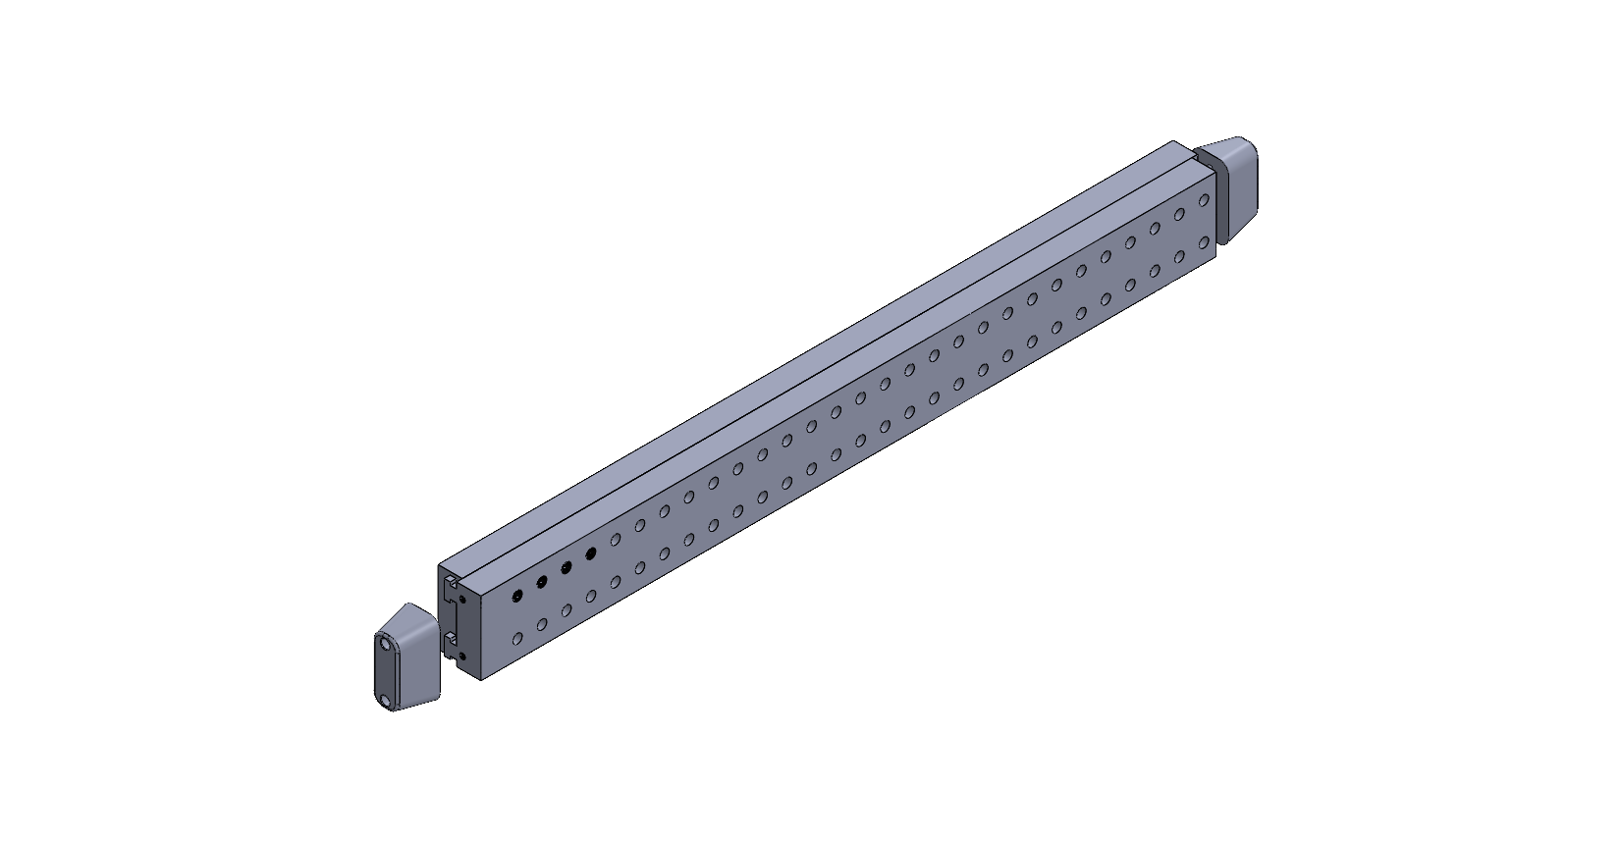

Figure 1010. Uni-track and Sliding Mount

As shown in figure 11, the Waveshare robotic arm will be mounted to the top of the case containing the electronics, positioning the base of the robotic arm near the hand of the user. The WaveShare RoArm-M2S is an affordable option compared to other models on the market, priced at $189.99. It features simplified controls due to its lower DOF, offers a reach of approximately 19.5 inches, and has a high torque capacity of 0.5 kg at max reach, all within a relatively, compared to the more popular Kinova robotic arm, compact design [10].

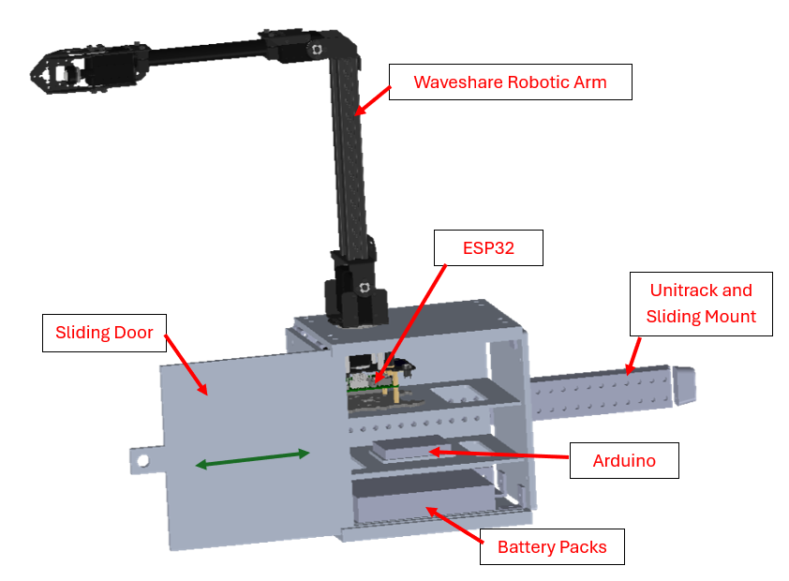

Figure 11. WaveShare RoArm-M2S Robotic Arm CAD Model Assembly

Due to its high degree of accuracy and low cost, the team decided to move forward with this robotic arm. Its long reach puts it well within our desired range of motion for interacting with buttons, and its lift of 500g at its maximum extension meets our required weight for carrying a cup of water. On top of all that, the arm is relatively lightweight and compact, reducing its bulkiness.

A benefit of using this arm is the built-in ESP32 microcontroller, which will act as an onboard processor for the rest of the arm. Tests involving this microcontroller will be performed initially with commands directly from a computer, which is a feature the arm has built in as part of its web application. Once sufficient tests have been performed, python will be used to allow for on board control in the form of a three-dimensional joystick, which will be connected to the ESP32 by the schematic shown in Figure 12. Should the ESP32 prove unable to perform the functions required of it, including forward kinematics and motion tracking, we also have drawn up plans to integrate an Arduino mega into the system, in which the Arduino will function as a secondary processor, taking inputs from the user, processing them, and then sending them to the arm. It will also take in feedback from the arm including joint position and angular velocity, factoring that into the ongoing calculations.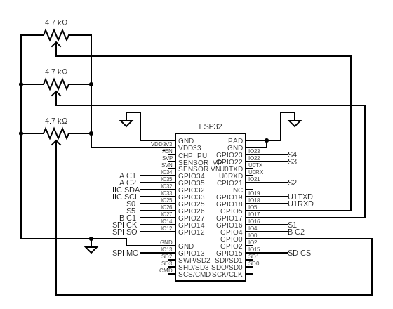

Figure 12. ESP32 Circuit Diagram

The calculated power draw from the WaveShare is 5-amp hours per hour if used at maximum capacity constantly. The batteries we have selected have a total 5200mAh capacity, which is why we will employ two in series to allow for full system use for a period of two hours, with an anticipated greater battery life depending on how frequently the user utilizes the arm. According to our calculations the battery life would allow for a day's casual use between recharging, which is within our specifications.

Future CAD modeling will encompass the final size requirements which will be determined by the parts purchased and further consultation with the sponsor. As powered wheelchair Unitrack’s are utilized for different applications, the current case dimensions will impede with any accessories a user may have on their chair. Team 205 will focus on obtaining further dimensional requirements in case the current accessories cannot be moved. The minimum width will be determined primarily by measuring and comparing the dimensions of the base of the WaveShare, the batteries and the microcontroller. The largest of the three will provide the team with the minimum workable footprint. Many different parts are still under consideration such as the batteries and Arduino microcontroller, which will largely be determined by tests performed after the arm is acquired. Once the team comes to an agreement on all purchase parts, a more accurate representation of the footprint can be modeled and created.

## Engineering Analysis and Prototyping

The team plans to utilize forward and inverse kinematics to calculate the position, orientation, and joint positions of the robot. As shown in equation (1), forward kinematics results in a transformation matrix (T) that displays the position vector (p) and orientation matrix (R) of the end effector in reference to the base of the robot.

|  |  |  |
| --- | --- | --- |
|  |  | (1) |

To calculate the transformation matrix, screws, vectors that display the linear and angular velocity of each joint obtained through the robot’s geometry, and the home position matrix (M), the transformation matrix showing the initial position and orientation of the robot also obtained through the robot’s geometry, are utilized in equation (2).

|  |  |  |
| --- | --- | --- |
|  | Inserting image... | (2) |

Therefore, through forward kinematics, given the joint positions, the position and orientation of the end effector relative to the base of the robot can be obtained.

|  |  |  |
| --- | --- | --- |
|  | Figure 13. WaveShare RoArm-M2S Robotic Arm Joint Diagram |  |

Inverse kinematicsdoes the opposite of forward kinematics. These calculations would allow us to find the joint positions required to produce a desired angular and linear velocity at the end-effector. As shown in figure 10, given the 3D coordinates of the end-effector relative to the base of the robotic arm, several equations (3), (4), and (5) can be obtained.

|  |  |  |
| --- | --- | --- |
|  |  | (3) |
|  |  | (4) |
|  |  | (5) |

The above equations are obtained through geometric analysis of the robot can be rearranged into equations (6), (7), and (8) to obtain the joint positions.

|  |  |  |
| --- | --- | --- |
|  |  | (6) |
|  |  | (7) |
|  |  | (8) |

Therefore, given a desired linear and angular velocity of the end-effector, through inverse kinematics, the required joint positions to produce the desired linear and angular velocities can be obtained.

### Electrical

As the system requires an external source to power it, calculations are necessary to determine the battery required based on its capacity ratings and charging times. The power draw required for the WaveShare robotic arm to operate may be easily calculated through the product of the voltage the arm requires with the amperage it requires at. This is seen through the WaveShare website recommends the usage of a $12V$& $5A$ power supply. The power requirement can be calculated from the following equation:

|  |  |  |
| --- | --- | --- |
|  |  | (9) |

This results in a power draw of $P=12V∙5A=60W$. To convert the power value to units of $mAh$, the units used to determine the energy charge a battery can hold, the team had to determine the cycling time between charge intervals [11]. This was determined to be a 24-hour period between charge intervals as per the sponsor from the assumption that the user would charge the arm daily. With the variables determined, equation 10 is used to convert the known power draw to a capacity draw in a full day under continuous loading.

|  |  |  |
| --- | --- | --- |
|  | $$mAh=\frac{W∙h}{V}∙1000$$ | (10) |

This results in the required battery capacity of $mAh=\frac{60W∙24h}{12V}∙1000=120,000 mAh$ for continuous loading. Since the arm is not expected to operate continuously for 24 hours, the team estimated an overall continuous usage of 3 hours per day. This brings down the required battery capacity from $120,000 mAh$ to $15,000 mAh$. Through this, the team determined that three $5,000 mAh$ batteries would work well for the robotic arm. The specific batteries selected are a type recommended by the WaveShare robotic Arm; A 3S lithium battery with a capacity of 5,200 $mAh$ [12]. To determine the charging time required for the system equation 11 is utilized.

|  |  |  |
| --- | --- | --- |
|  | $$Recharge Time=\frac{mAh battery capacity [mAh]}{mA of charge current [mA]}$$ | (11) |

The charger suitable for the batteries selected can charge up to $27V$ at $10A$ [13]. This results in a recharge time of $\frac{15,600 mAh}{10,000 mA}\sim 1 h 30min$.

### Structural

The team plans to refine engineering analysis as designs are finalized, parts are acquired, and prototyping begins. As dimensions are yet to be finalized due to variables in the size of the mounting arm and Uni-track length, accurate stress analysis would be difficult to produce. However, a general model may be produced to give a general estimate of stresses induced onto the Uni-track mounting bracket and confidence can be built in determining whether aluminum as a material choice is applicable with the constraints known. Once stress values are calculated, they can be compared to the yield strength of pure aluminum providing a larger factor of safety in calculated values. Taking the weakest type of aluminum as our test value, pure aluminum starts to yield at 30 MPa, which implies a shear yield strength of 17.32 MPa according to the von mises yield criterion, as indicated by Equation 12. [14].

|  |  |  |
| --- | --- | --- |
|  | $$τ_{yield }=\frac{σ_{yield}}{\sqrt{3}}$$ | (12) |

The team began by creating general estimates of weight, horizontal distance from mounting point, and moments of inertia for common shapes. The following unknowns will be approximated based on the current known data. The weights of the WaveShare arm and a single 3S lithium battery are 1.85 lb and 0.83 lb, respectively, as provided by the manufacturers. The estimated maximum weight of the case is approximately 29.6 lb when case dimensions are built to the maximum width length of 13 in from the Uni-track mount. The Uni-track has an estimated length of 24 in. This leaves the user with a total unloaded weight of approximately 34 lb ~ 15.4 kg which will act upon the center of the case located 7.5 in ~ 0.19 m away from the Uni-track mount. By utilizing equations 13,

|  |  |  |
| --- | --- | --- |
|  | $$σ_{bending}=\frac{M∙c}{I}$$ | (13) |

and equation 13,

|  |  |  |
| --- | --- | --- |
|  | $$τ=\frac{F}{A}$$ | (14) |

sheering and bending stresses may be approximated at the Uni-track mount. With an estimated Uni-track dimension of $1.5 in x 0.75 in x 24 in$ ~ $0.038 m x 0.019 m x 0.61 m$, the moment of inertia $I$ which rotates about the vertical plane parallel to the wheelchair armrest can be calculated using equation 15,

|  |  |  |
| --- | --- | --- |
|  | $$I=\frac{b∙h^{3}}{12}$$ | (15) |

Where b = 24 in ~ 0.61 m and h = 1.5 in ~ 0.038 m. This now allows for the calculation of area A, moment M, and moment of intertia I. The area needed to calculate shearing in the Uni-track rail would be the front face of the Uni-track mount $A=0.038 m x 0.61 m=0.023 m^{2}$. The moment $M$ is simply equal to the force of gravity multiplied by the distance to the center mass. This results in $M=F∙R=15.4 kg∙9.8\frac{m}{s^{2}}∙0.19 m=28.67 N∙m$. $I$ is found to be $I=\frac{0.61 m ∙{\left(0.038 m\right)}^{3}}{12}=2.789∙{10}^{-6}m^{4}$ and $c=0.019 m.$ With all variables determined $σ_{bending}$ and $τ$ can be determined.

|  |  |  |
| --- | --- | --- |
|  | $$σ_{bending}=\frac{28.67N∙m∙0.019 m}{2.789∙{10}^{-6} m^{4}}=195.3 kPa$$ | (13a) |

|  |  |  |
| --- | --- | --- |
|  |  | (14b) |

As both values of bending and sheering stress do not exceed the yield strength or shear yield strength for pure aluminum, the Uni-track mount will not fail under

# Risk and Mitigation Plan

Table 33. Risk Cube

|  |  |  |  |  |  |  |
| --- | --- | --- | --- | --- | --- | --- |
|  |  | **Unmitigated Risks** | | | | |
| Likelihood | 5 | 1 | 0 | 0 | 0 | 0 |
| 4 | 0 | 0 | 0 | 0 | 1 |
| 3 | 0 | 0 | 1 | 1 | 1 |
| 2 | 0 | 1 | 1 | 1 | 1 |
| 1 | 0 | 0 | 0 | 1 | 0 |
|  |  | 1 | 2 | 3 | 4 | 5 |
|  |  | Severity | | | | |

The risks for the project are broken into three categories: physical risks, programming risk, and electrical risk. The first physical risk is the shearing of bolts and welds at the robot mount location on the wheelchair, which will be mitigated by completing a stress/strain analysis on the bolts that mount the robot arm to the Uni-track, and the welds that provide structure for the robotic arm on the mount. Another similar risk is buckling/bending of robotic arm members due to excessive load or improper use, which will be mitigated by choosing an arm that uses materials rated for high stress applications. The last physical operating risk is if the arm exceeds the allowed range of operation, which will be mitigated by mechanical and electronic stops and limiters. Water damage is also a risk considered that will be mitigated by using materials with ingress protection ratings of IP 65, which is protected against dust and protected against water being sprayed at the system.

The first programming risk is if a programmed function exceeds the expected operating time (gets stuck in a loop) which will be mitigated by programming an arbitrary time limit that compares function operating time to this value and ends all operation if the function time exceeds this limit. This ensures that the robot will not repeat actions such as moving a water bottle between two points indefinitely. The second programming risk is if a delay between the robotic arm and joystick causes inaccuracy in performing functions, which will be mitigated by configuring sensitivity of the joystick to account for any delay.

Since the system has motors, batteries, processing equipment and sub-systems for controlling power, it is important to consider the risks associated with electrical equipment failure. Electrical components can overheat, causing technical or electrical failure and deformation of parts. Overheating will be mitigated through material choice and proper ventilation implementation. Additionally, it is possible that power surges through the system when the battery is first connected, so the team will include a breaker (switch) between the battery and the rest of the system to mitigate any effects from an electrical surge.

# Project Management

## Schedule

Initially, Team 205 began with the intent of modifying a low-cost robotic arm to assist motorized chair users. Most of the fall semester progress consisted of proposed needs, design concepts, risk and mitigation strategies, and additional details that were evaluated with the help of the faculty advisor and sponsor team. Throughout the completion of these assessments, the team was conceptually challenged to think outside the box, for example, the team was tasked with generating concepts that were not robotic arms. Overall, the team was able to successfully complete quality assignments leading into the Preliminary Design Review (PDR).

Currently, the team is on schedule and prepared to begin work for Critical Design Review (CDR) upon completion of PDR. Within the next few weeks, the team will begin phases of prototyping and engineering calculations. For prototyping purposes, the team will use 3D printing to test the dimensions and fitment of the components. In doing so, the evaluation and selection of heat sinks, electrical elements, and hardware will be conducted. With the completion of a high-fidelity prototype, engineering calculations such as load-bearing capacity, stress analysis, faster torque, and inverse kinematics will be calculated. However, these examples only highlight a few of the many engineering calculations that will be considered. Additionally, to ensure the team is prepared to construct the design in the spring, parts such as Arduino’s, the Waveshare robotic arm, and batteries will be ordered. The completion of prototyping, engineering calculations, and ordering parts will give the team confidence in a design ready for manufacturing in the spring.

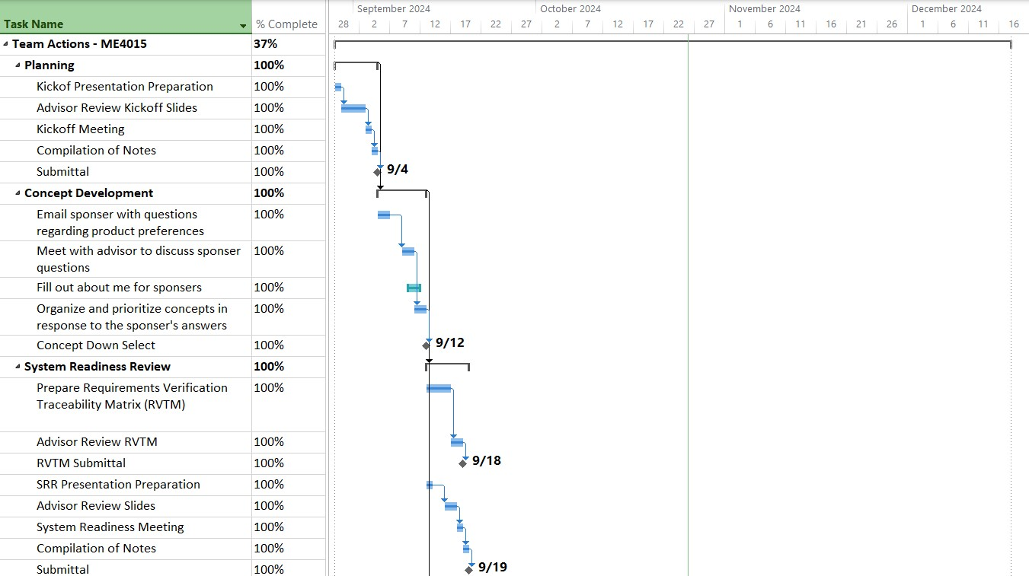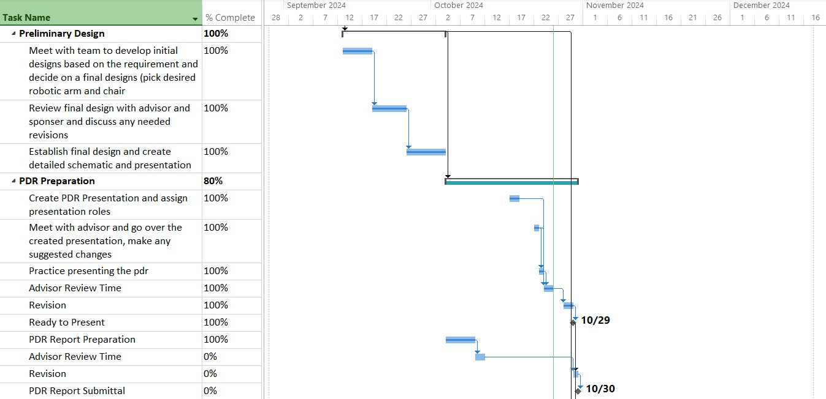

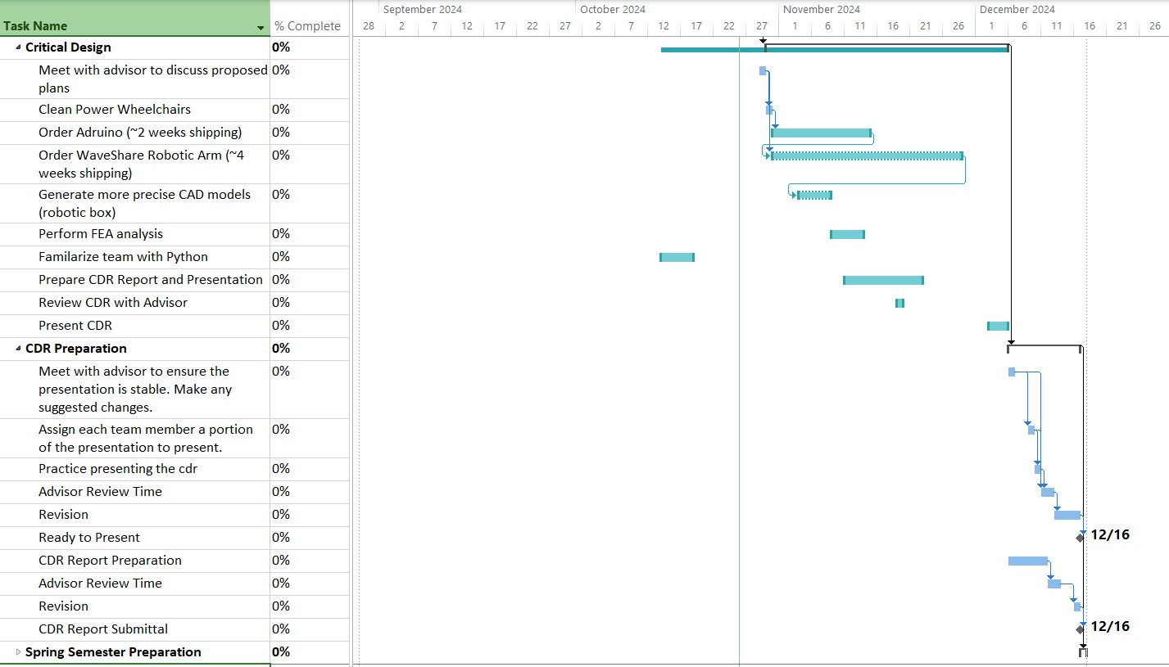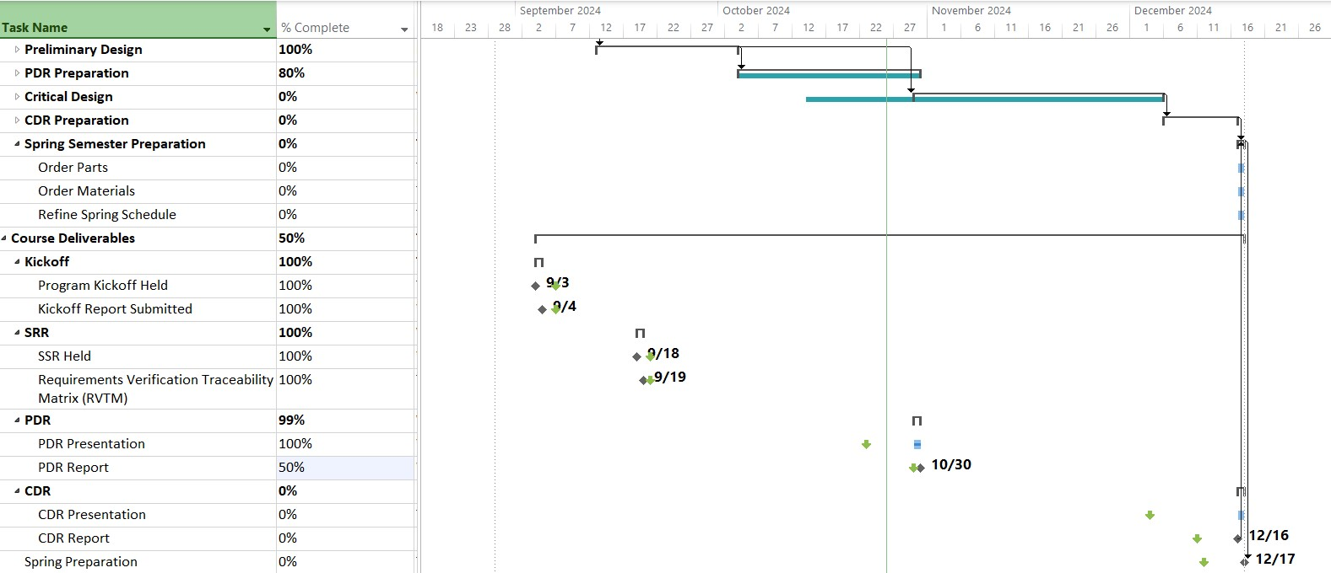

Figure 14. Gantt Chart

## Budget

The team has been allocated a maximum budget of $5,000 and the team is solely responsible for allocating expenses for parts and materials while also maintaining emergency funds. For planning purposes, an Excel spreadsheet, as shown in Figure 15, was created to establish a ledger and track purchases made by team 205. The spreadsheet automatically updates the projected and available budget based off items entered into the table, allowing the team to remain knowledgeable on current budget expenditure and plan future purchases accordingly. It also allows for record of which items have been received by the team and which are still in transit.

Similarly in Figure 16, a visualized budget expenditure is used to track the budget over the following months. As previously mentioned, many parts such as the robotic arm, batteries, Arduino, wire, and raw mounting materials will be ordered within the upcoming weeks of November for spring preparation, which is projected to cost around $975 total. Since December consists mostly of winter break, no spending will occur during this period. As the project continues into the spring semester, the team will likely need to order additional raw materials and replacements parts that are damaged through prototyping and testing. Budget is allocated for expenses in February, March, and April for unplanned purchases, with this allocation decreasing each month. The team projects a total budget usage of around $1650 for all parts and unplanned expenditures, therefore the team will not exceed the allotted budget of $5000.

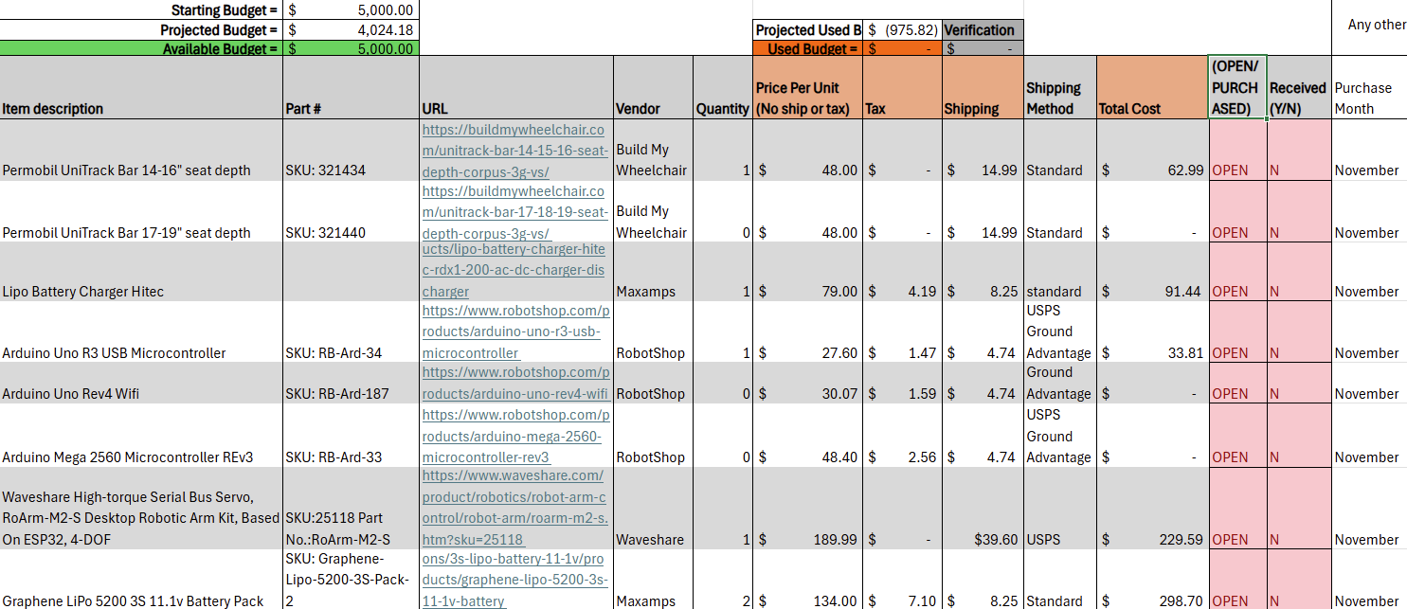

Figure 15. Budget Excel Spreadsheet

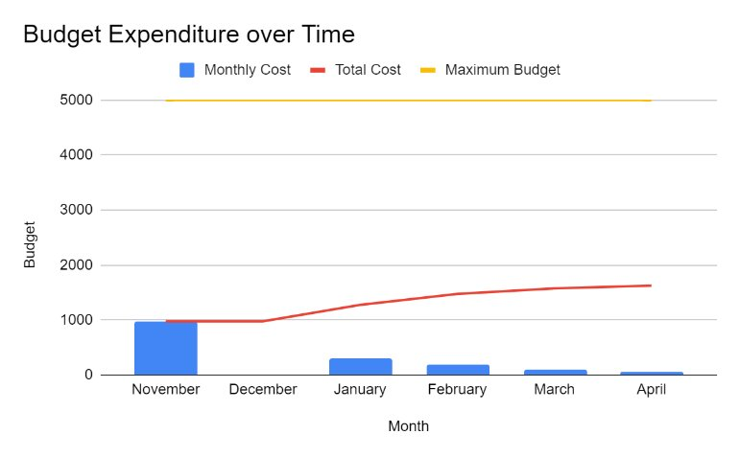

Figure 16. Budget Expenditure Chart

# Conclusions and Future Work

In conclusion of PDR, the team has learned much regarding robotic arms, powered wheelchairs, and their importance to users with DMD. More specifically, the ease of robotic manipulation is essential for intuitive controls to allow easier access to ROM capabilities. Similarly, the most common wheelchairs within the DMD community are the Permobil M3 and the Quantum which will be replicated and used as our testing platform to guarantee we are designing specially for the end users. The team has also gained vast knowledge of life with DMD through communication with the sponsor team. These discussions have aided the team in selecting a final concept as well as evaluating its risk and associated mitigation strategies.

Moving forward with the robotic arm design, within the next six months, the team will design a mounting bracket that attaches the robotic case to the side of the wheelchair. Similarly, the team will also design a joystick mount that will be attached on top of the robotic case. Prior to winter break, the team will fabricate engineering drawings to capture proper dimensions and manufacturing processes of the mounting bracket, robotic case, and joystick mount. These engineering drawings will also provide the capability to perform accurate FEA analyses. The mounting bracket, robotic case, and joystick mount willbe manufactured by the team early in the spring semester. The team will also integrate the Waveshare robotic arm and its control system onto the robotic case and joystick mount, respectfully. To do so, the team will first order the Waveshare robotic arm and its control system (joystick), which will be ordered by mid-November with an estimated shipping time of two weeks through Amazon. This timeframe will provide the ability to conduct quality checks and develop testing procedures before leaving for winter break. Additionally, over the upcoming weeks, the team will continue to practice with Python syntax and learn Arduino integration with ESP32 such that these skills are ready to be applied in the spring.

In the spring semester, a series of modifications will be made to the Jazzy wheelchair to replicate the mounting schematic of a Permobil M3 wheelchair. These modifications will be primarily done through the manufacturing and implementation of the mounting bracket. Ideally, the mounting bracket, robotic case, and joystick mount will be manufactured by the end of February. Through the week leading up to manufacturing, the team will re-familiarize themselves with any equipment they might utilize. Upon successful inspections and completion of the manufactured items, the robotic arm and its control system will be integrated onto the robotic case and joystick mount by the end of March. This includes implementing hardware and any electronics such as wires, batteries, and Arduinos. Next, the team will shift focus towards programming the Waveshare robotic arm to complete desired tasks. This programming phase will lead up until the end of the spring semester, it will require the team to apply knowledge regarding Python syntax and robotic automation such as inverse kinematics. In conclusion, the team is on track to meet the high-value functions of pushing an elevator and handicap door button. The team will continue to work closely with the sponsor to ensure we are continuously and progressively meeting their proposed needs.

# References

[1] “Robotic arm,” Kinova, <https://assistive.kinovarobotics.com/product/jaco-robotic-arm> (accessed Oct. 8, 2024).

[2] JACO® Assistive Robot user guide R7.1, https://assistive.kinovarobotics.com/uploads/EN-UG-007-Jaco-Assistive-robot-user-guide-r7.1.pdf (accessed Oct. 18, 2024).

[3] “What you need to know,” Parent Project Muscular Dystrophy, <https://www.parentprojectmd.org/care/for-families/for-newly-diagnosed/what-you-need-to-know/> (accessed Oct. 8, 2024).

[4] “U.S. Access Board,” ADA Accessibility Standards, https://www.access-board.gov/ada/#ada-404_2_7 (accessed Oct. 29, 2024).

[5] A. Zhang and Y. Li, “Thermal conductivity of aluminum alloys-A Review,” MDPI, https://www.mdpi.com/1996-1944/16/8/2972 (accessed Oct. 29, 2024).

[6] “Filament Properties Table,” Simplify3D Software, https://www.simplify3d.com/resources/materials-guide/properties-table/ (accessed Oct. 29, 2024).

[7] “Optimizing strength of 3D printed parts,” 3d Pros, https://3dpros.com/guides/optimizing-part-strength (accessed Oct. 29, 2024).

[8] “Jaco Assistive Robotic Arm: How to Use it to Take a Drink,” YouTube, https://www.youtube.com/watch?v=THFELtNNShM (accessed Oct. 29, 2024).

[9] “Metal spot price charts aluminum price chart (USD / kilogram) for the last available years,” Daily Metal Price: Aluminum Price Chart (USD / Kilogram) for the Last Available years, https://www.dailymetalprice.com/metalpricecharts.php?c=al&u=kg&d=0 (accessed Oct. 29, 2024).

[10] Waveshare, <https://www.waveshare.com/product/robotics/robot-arm-control/roarm-m2-s.htm> (accessed Oct. 29, 2024).

[11] R. Sheldon, “What is milliampere-hour (mah)?: Definition from TechTarget,” WhatIs, https://www.techtarget.com/whatis/definition/milliampere-hour-mAh#:~:text=Robert%20Sheldon-,What%20is%20milliampere%2Dhour%20(mAh)?,is%20equivalent%20to%201%20coulomb. (accessed Oct. 29, 2024).

[12] “Graphene Lipo 5200mah 3s 11.1V battery pack,” MaxAmps Lithium Batteries, https://maxamps.com/collections/3s-lipo-battery-11-1v/products/graphene-lipo-5200-3s-11-1v-battery (accessed Oct. 29, 2024).

[13] “Lipo Battery Charger hitec RDX1 200 AC/DC Charger/Discharger,” MaxAmps Lithium Batteries, https://maxamps.com/collections/lipo-battery-charger/products/lipo-battery-charger-hitec-rdx1-200-ac-dc-charger-discharger (accessed Oct. 29, 2024).

[14] Sunrise, “Yield strength of aluminum alloys - al alloy yield strength chart,” Sunrise Metal - Aluminium Die Casting Expert, https://www.sunrise-metal.com/yield-strength-of-aluminum-alloys/#:~:text=Pure%20Al%20(at%20least%2099,for%20utilizing%20aluminum’s%20elemental%20benefits. (accessed Oct. 29, 2024).

# Appendices

A.1 System Architecture

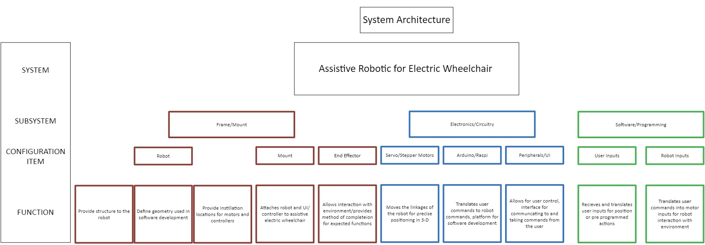

A.2. Individual Concepts

A.2.a. Justin Concepts

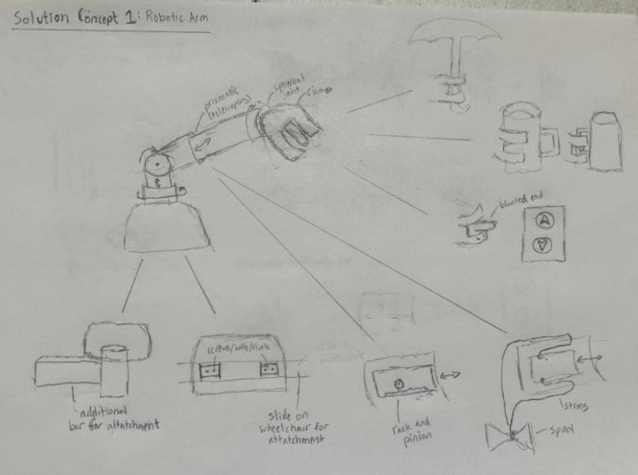

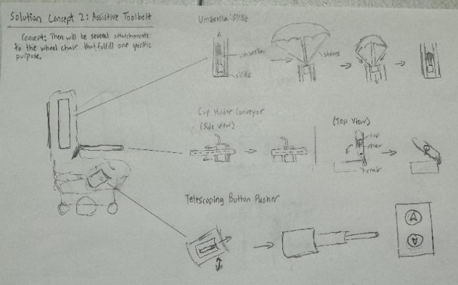

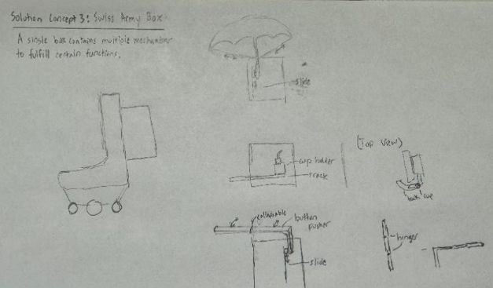

A.2.b Andrew Concepts

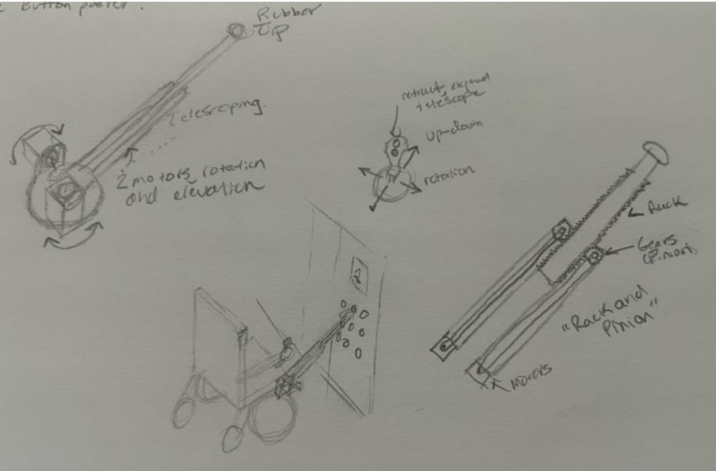

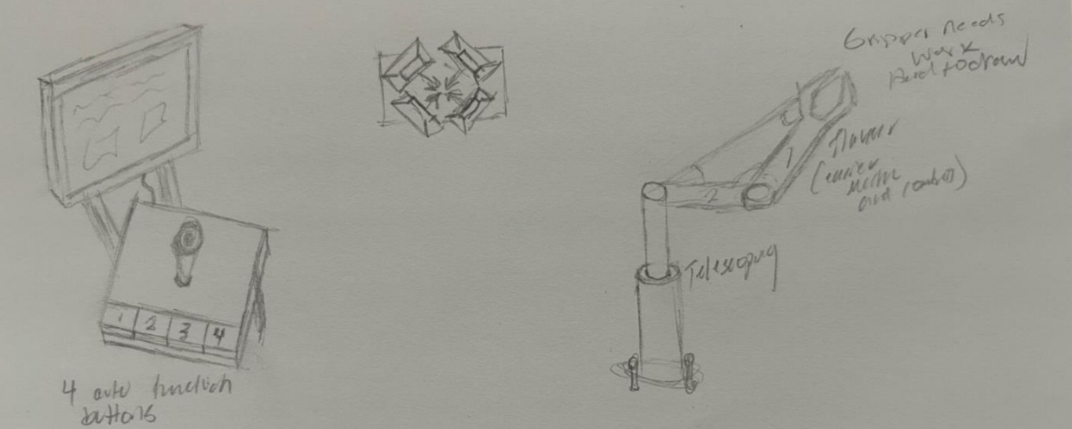

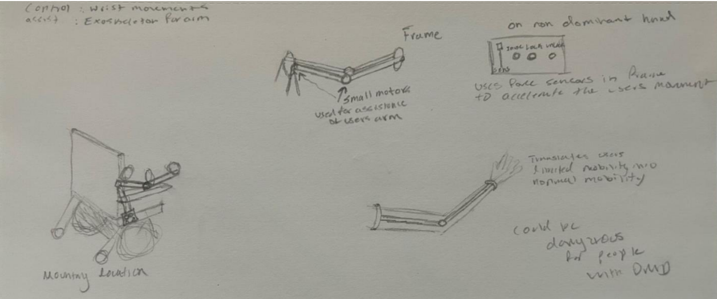

A.2.c Brooke Concepts

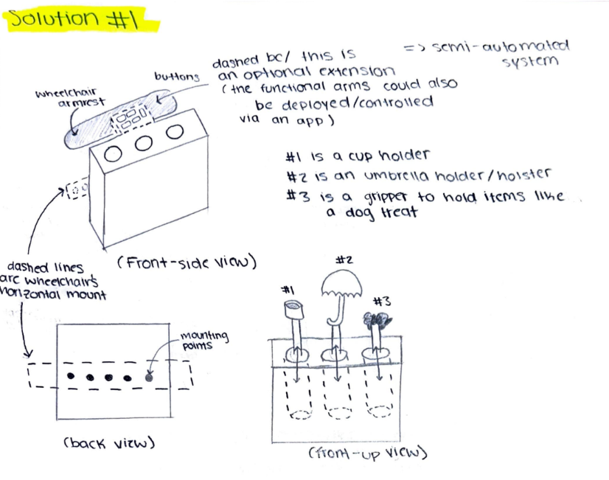

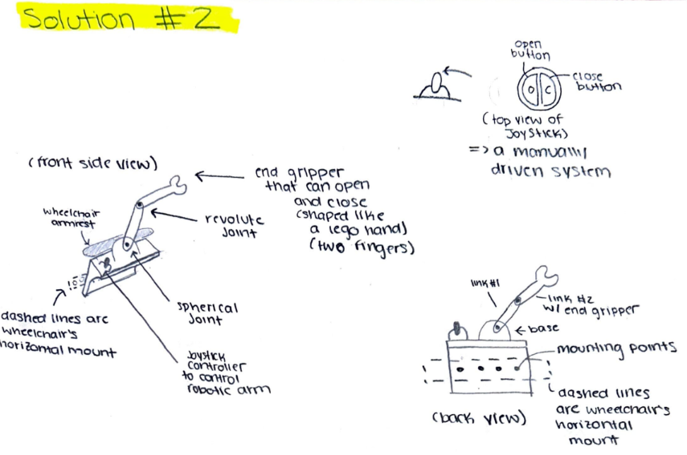

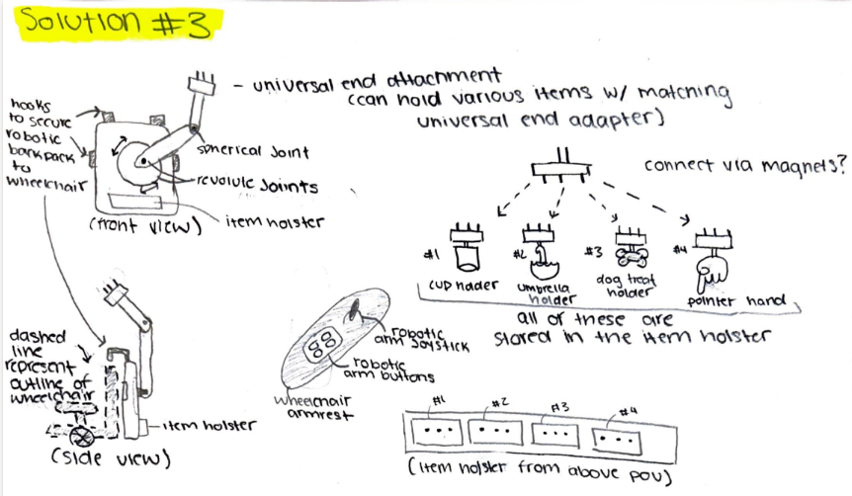

A.2.d Omar Concepts

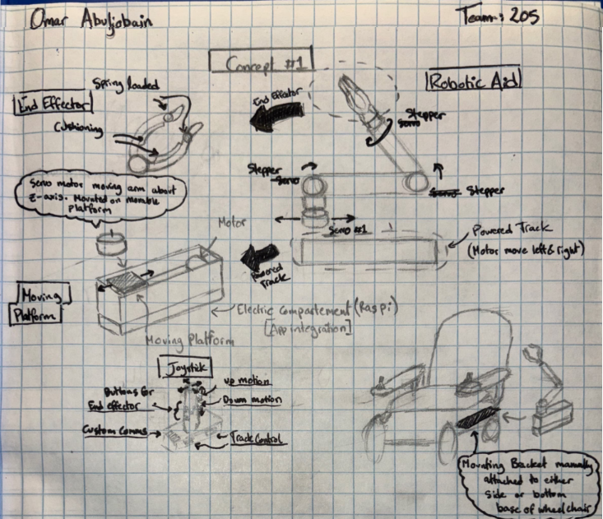

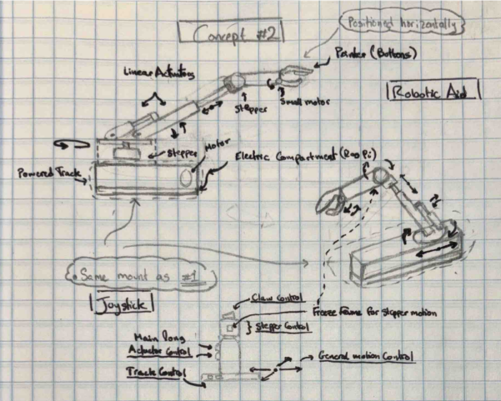

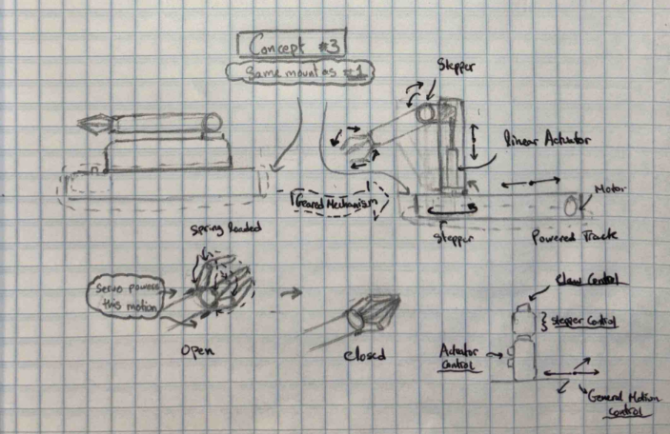

A.2.e Cavan Concepts

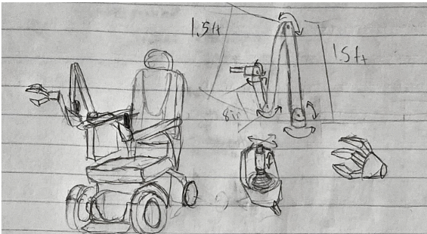

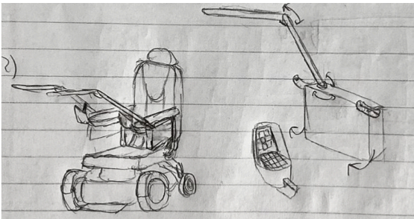

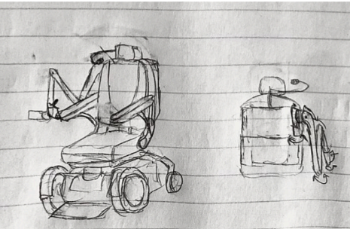

A.3 Visualized Electronics

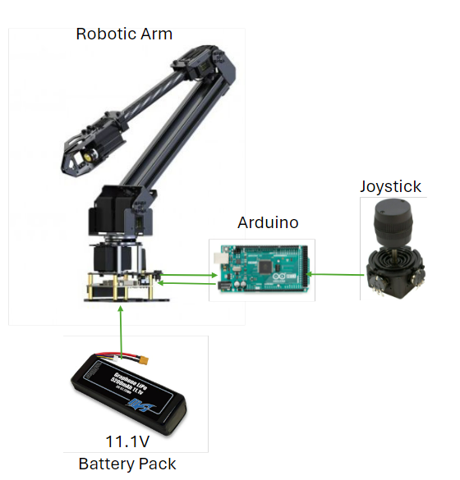

A.4 ESP32 GPIO Map



A.5 Equations used for Forward and Inverse Kinematics Analysis

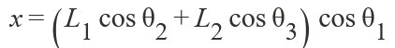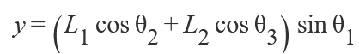

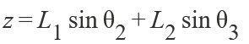







A.6. Visualized Joint Locations used in Kinematic Analysis

